

STUDENT NAME: EVANS KIPKOECH BETT
REG. NO: BSCCS/2024/59226
COURSE: B. COMPUTER SCIENCE
UNIT CODE: BIT4138
UNIT NAME: ADVANCED CRYPTOGRAPHY
SUPERVISOR: MICHEAL NYORO
ACADEMIC YEAR: YEAR 3, SEM II
PROJECT TITLE: SECURE FILE SHARING SYSTEM USING ENCRYPTION
SELECTED TECHNOLOGIES
Python
Cryptography Library
OpenSSL
PyCryptodome
GITHUB REPOSITORY: https://github.com/Evans-Bett/cryptography-project

Table of contents
WEEK ONE: CRYPTOGRAPHY ENVIRONMENT SETUP .................................................................... 4
Title: Installation and Configuration of Cryptography Development Environment ………………...... 4
FIG 1: Python and VS Code installation ......................................................................................... 4
FIG 2: Cryptography libraries installed .......................................................................................... 4
FIG 3: OpenSSL installation test .................................................................................................... 5
FIG 4: Local encryption script ........................................................................................................ 5
FIG 5: GitHub repository initialization ........................................................................................... 5
Student Reflection ........................................................................................................................ 6
WEEK 2: CLASSICAL CRYPTOGRAPHY AND CIPHER DESIGN .......................................................... 7
Title: Implementation of Classical Encryption Algorithms ………………………………........................... 7
FIG 1: Caesar cipher implementation ........................................................................................... 7
FIG 2: Vigenère cipher encryption process .................................................................................. 8
FIG 3: Encryption and decryption output .................................................................................... 8
FIG 4: User input validation interface ………………………………………….............................................. 9
FIG 5: Cipher testing results ………………………………………………....................................................... 9
Student Reflection ...................................................................................................................... 10
WEEK 3: STREAM CIPHERS AND RANDOMNESS TESTING ……………………………............................. 11
Title: Implementation of Stream Cipher Systems and Random Sequence Analysis ................... 11
FIG 1: LFSR generator implementation ....................................................................................... 12
FIG 2: Pseudorandom sequence output ..................................................................................... 12
FIG 3: Statistical randomness testing ......................................................................................... 12
FIG 4: RC4 stream cipher simulation .......................................................................................... 13
FIG 5: Encryption performance results ....................................................................................... 13
Student Reflection ...................................................................................................................... 14
WEEK 4: BLOCK CIPHER DESIGN AND AES ................................................................................. 15
Title: AES and Block Cipher Operations ...................................................................................... 15
FIG 1: AES encryption .................................................................................................................. 15
FIG 2: Key generation process ..................................................................................................... 16
FIG 3: File encryption demonstration ......................................................................................... 16
FIG 4: Decryption results ............................................................................................................ 17
FIG 5: Performance testing ......................................................................................................... 17
Student Reflection ...................................................................................................................... 18
WEEK 5: PUBLIC KEY CRYPTOGRAPHY (RSA) .............................................................................. 19
Title: Implementation of RSA Encryption and Key Management .............................................. 19
FIG 1: RSA key pair generation ................................................................................................. . 19
FIG 2: Public key encryption process .......................................................................................... 20
FIG 3: Private key decryption results ......................................................................................... 20
FIG 4: Secure message transmission .......................................................................................... 21
FIG 5: RSA testing and validation ................................................................................................ 21
Student Reflection ...................................................................................................................... 22

WEEK ONE: CRYPTOGRAPHY ENVIRONMENT SETUP
TITLE:
Installation and configuration of cryptography development environment
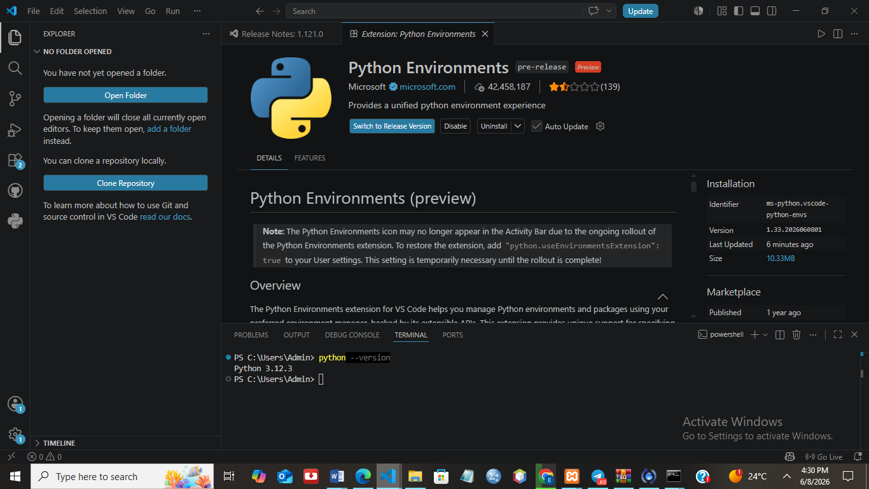
Fig 1: Installation of Python and VS Code
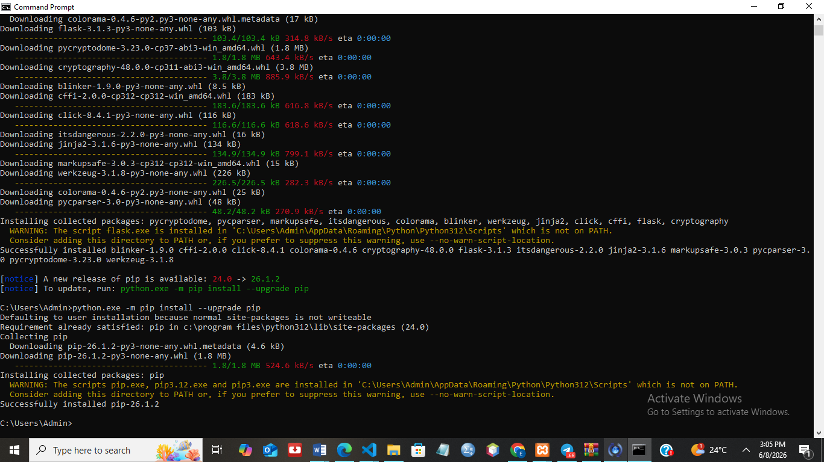
Fig 2: Installation of Cryptography Libraries
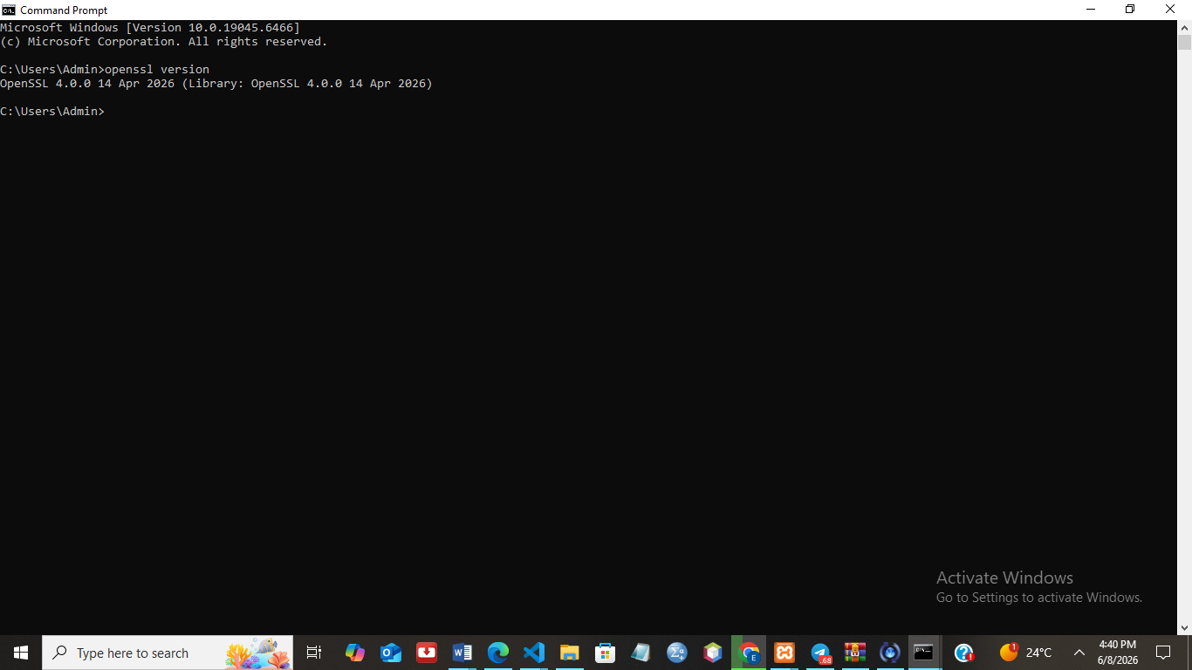
Fig 3: OpenSSL Installation Test
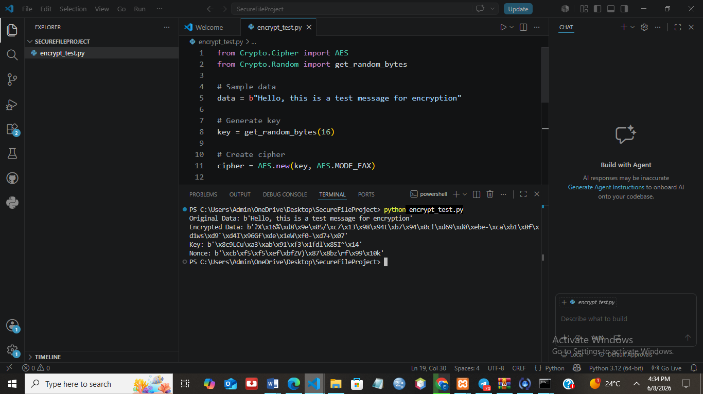
Fig 4: Local Encryption Script Execution
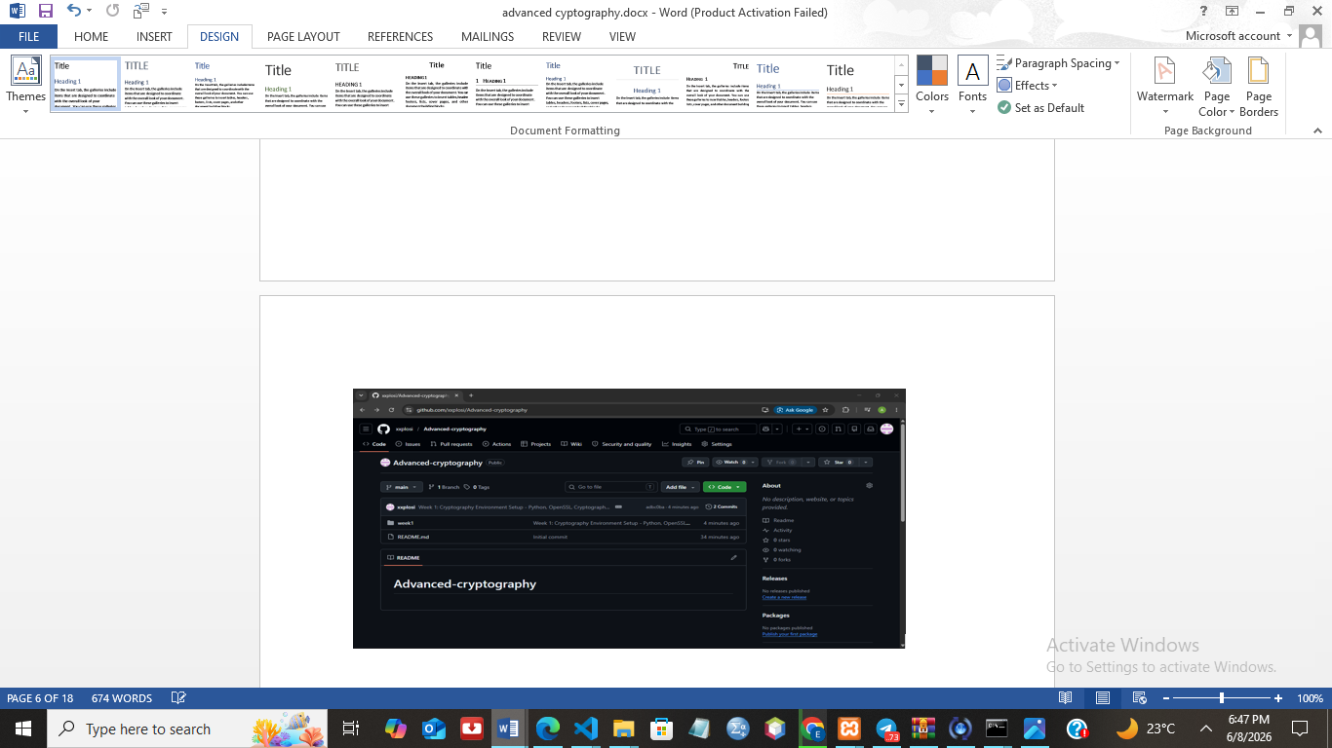
Fig 5: GitHub Repository Initialization

STUDENT REFLECTION
This week, I set up the development environment by installing Python, VS Code and the required cryptography libraries. I also configured OpenSSL and created a GitHub repository. The setup was successful and prepared me for implementing encryption features in the project.

WEEK TWO: CLASSICAL CRYPTOGRAPHY AND CIPHER DESIGN
Title:
Implementation of Classical Encryption Algorithms
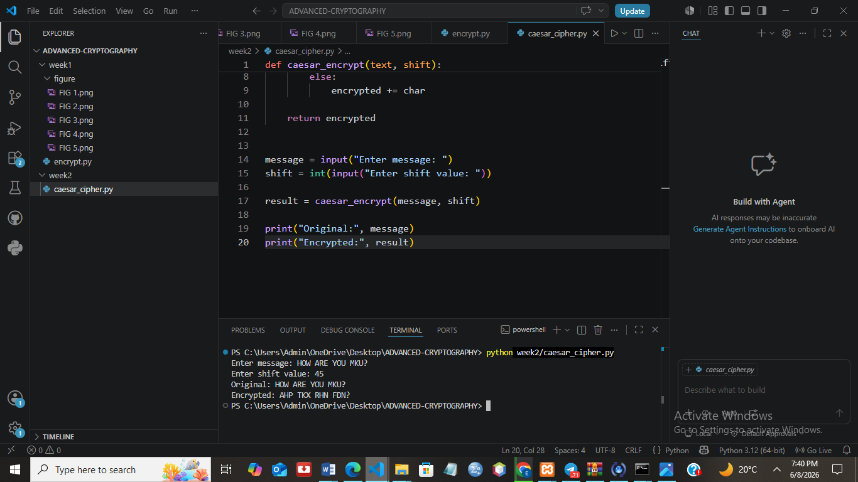
Fig 1: Caesar Cipher Implementation
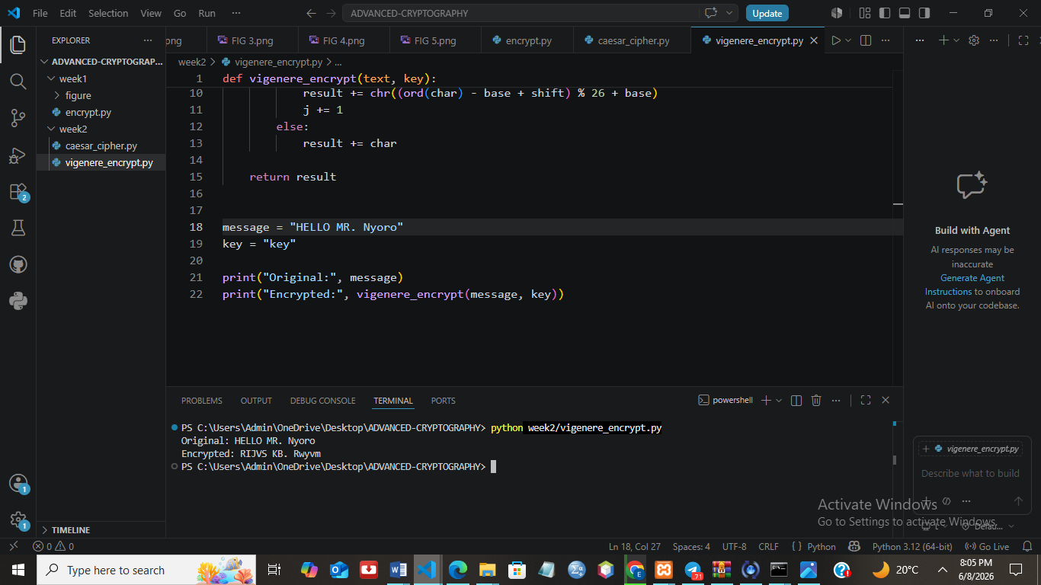
Fig 2: Vigenere Cipher Encryption Process
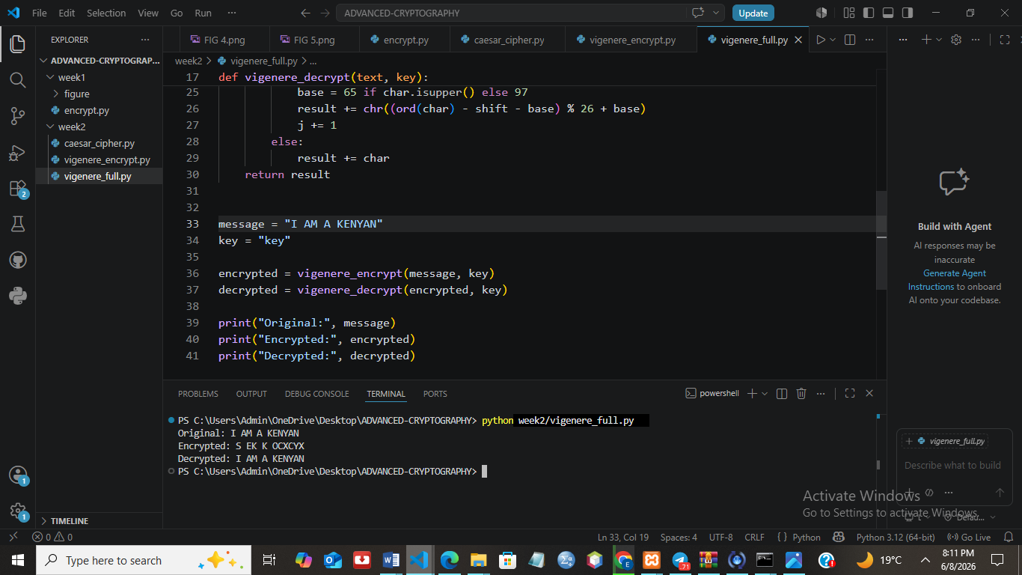
Fig 3: Encryption and Decryption Output
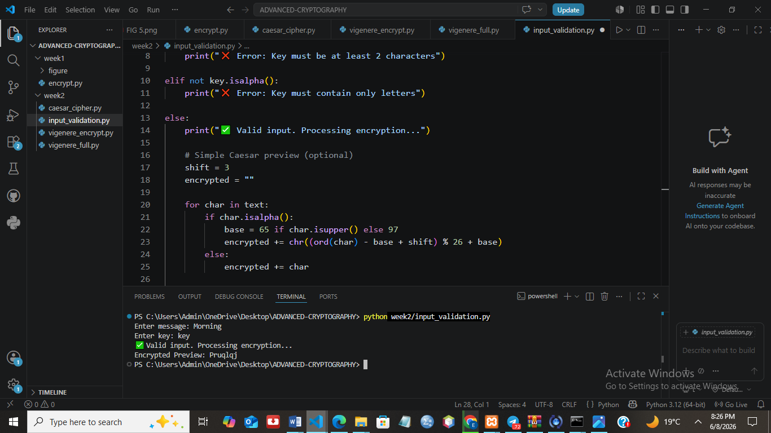
Fig 4: User Input Validation Interface
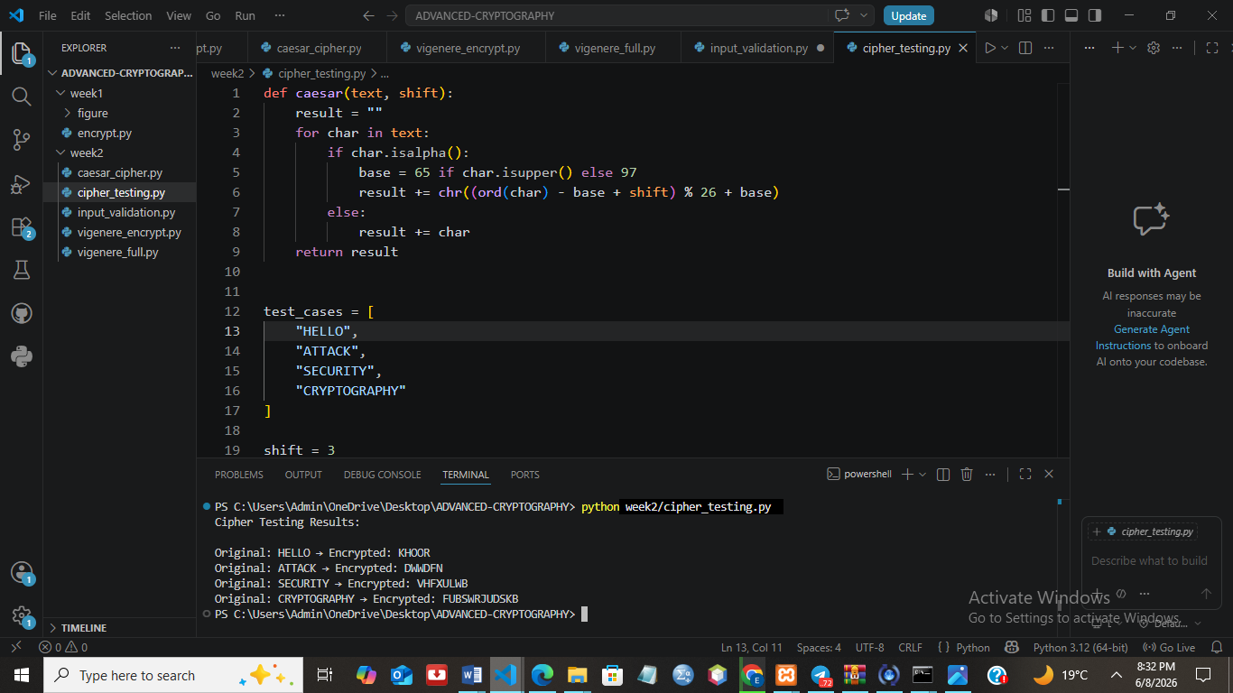
Fig 5: Cipher Testing Results

STUDENT REFLECTION
This week I worked on simple encryption methods like Caesar and Vigenère ciphers. I learned how messages are scrambled using different keys and how easy it is to break old encryption systems. It helped me understand why stronger modern encryption methods are needed for real security.

WEEK THREE: STREAM CIPHERS AND RANDOMNESS TESTING
Title:
Implementation of Stream Cipher Systems and Random Sequence Analysis
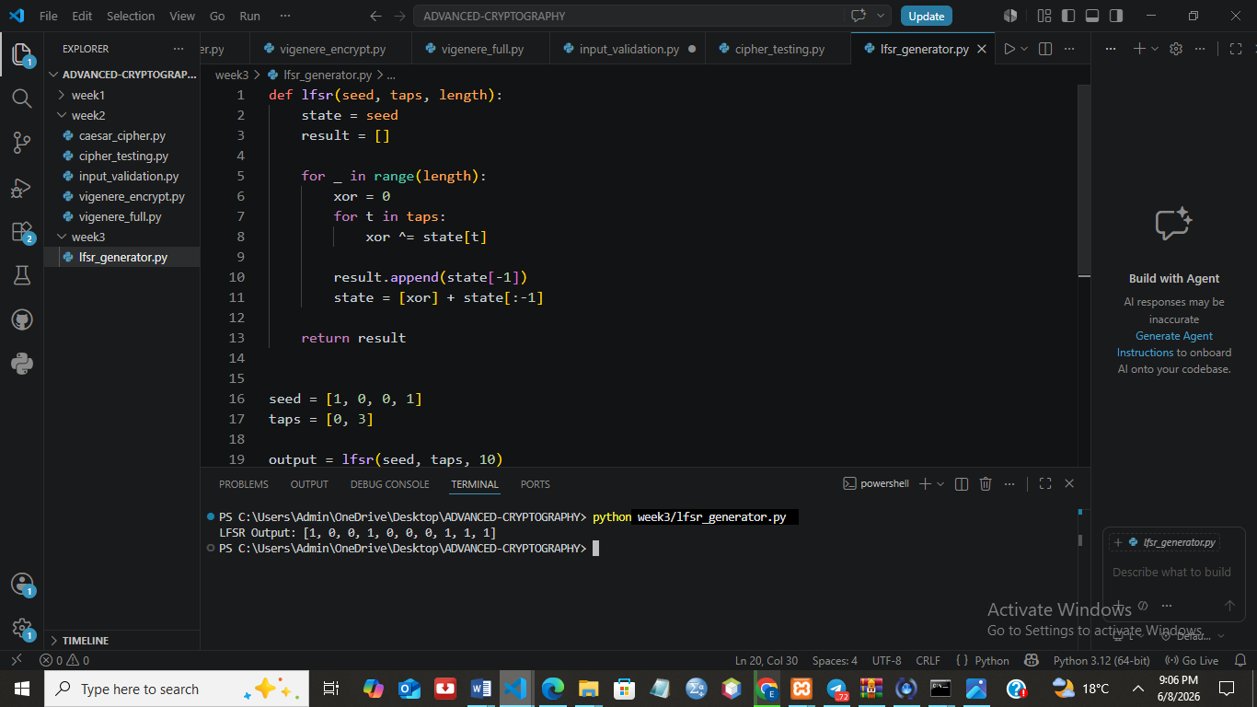
Fig 1: LFSR Generator Implementation
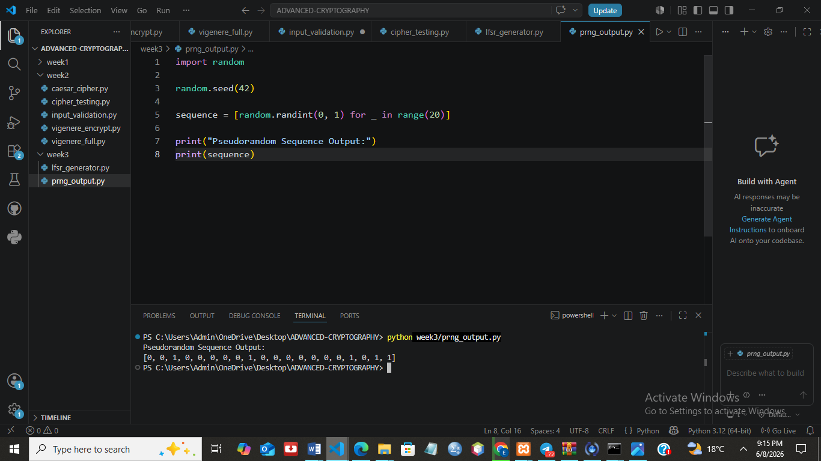
Fig 2: Pseudorandom Sequence Output
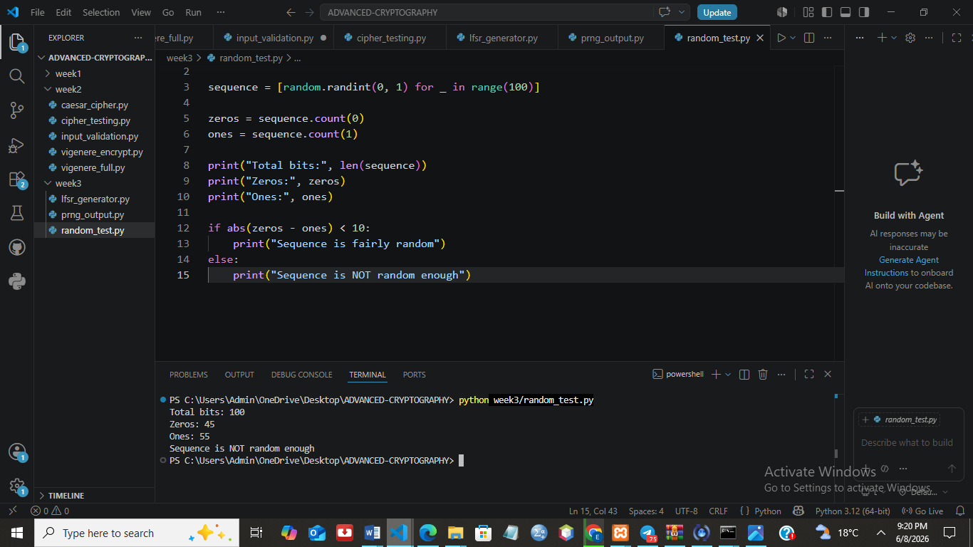
Fig 3: Statistical Randomness Testing
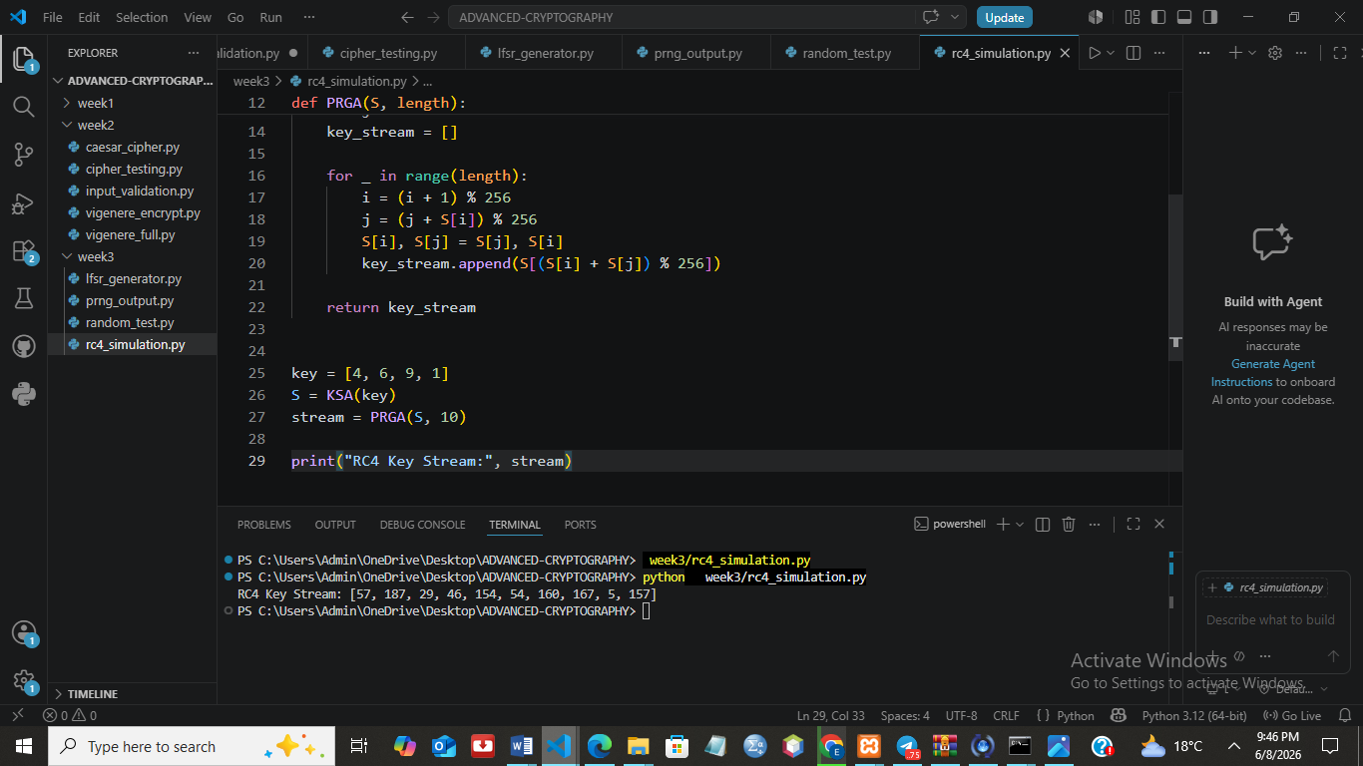
Fig 4: RC4 Stream Cipher Simulation
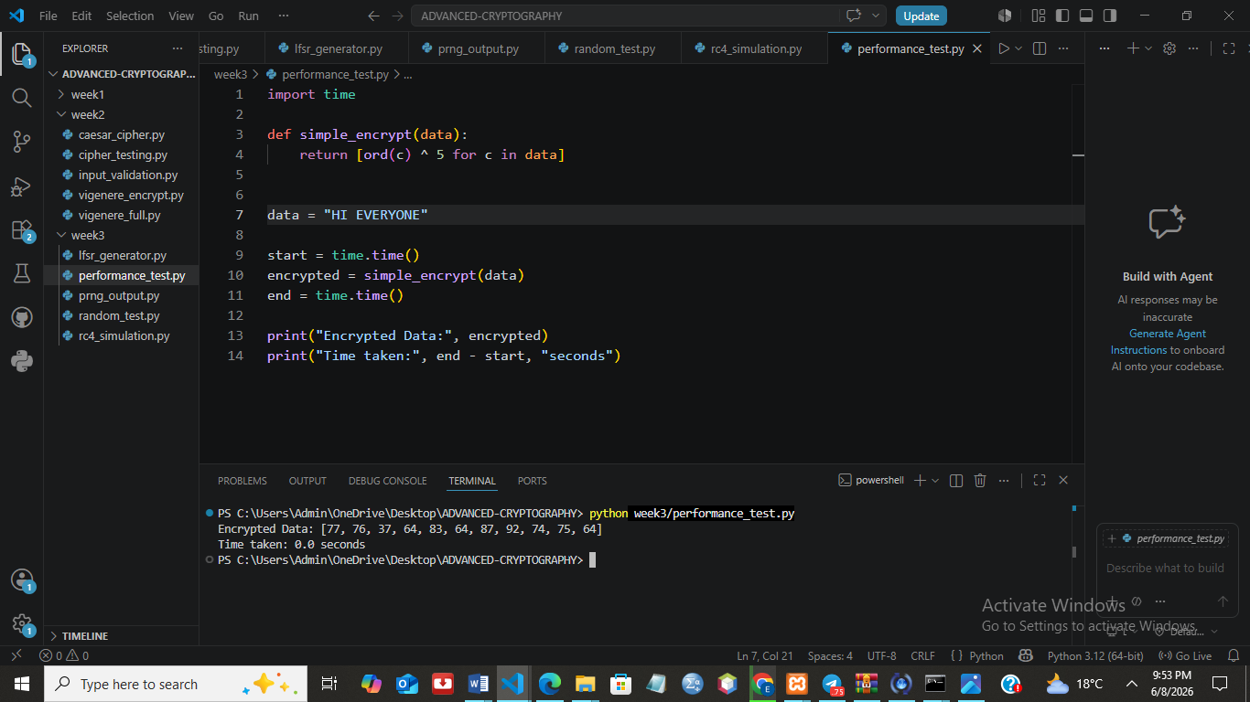
Fig 5: Encryption Performance Results

STUDENT REFLECTION
This week, I explored stream ciphers and randomness testing. I learned how pseudorandom sequences are generated using LFSR and how RC4 uses these sequences for encryption. The activities helped me understand the importance of randomness in cryptography and its role in improving data security.

WEEK FOUR: BLOCK CIPHER DESIGN AND AES
Title:
Advanced Encryption Standard (AES) and Block Cipher Operations
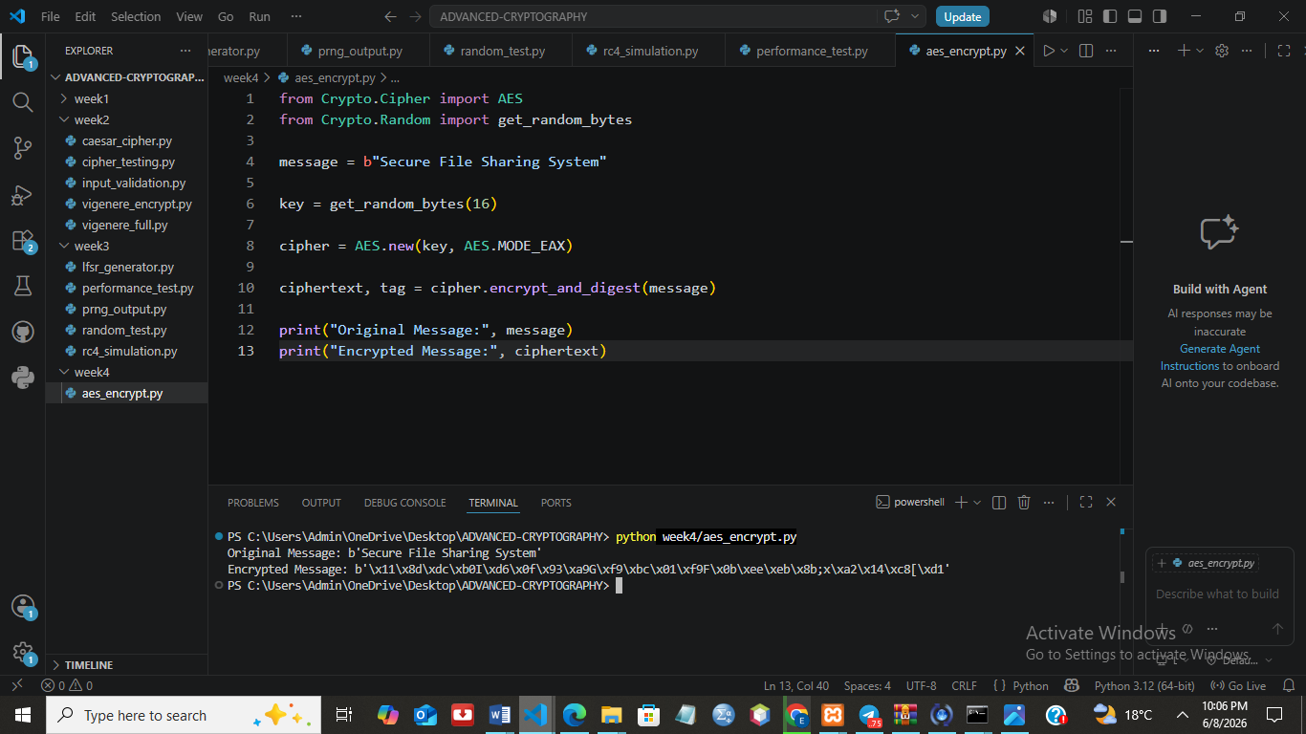
Fig 1: AES Encryption Script
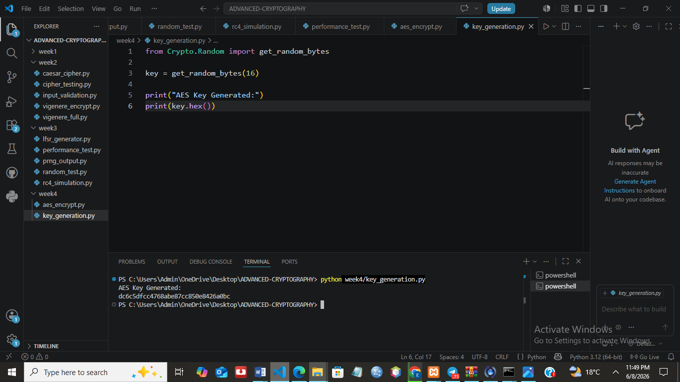
Fig 2: Key Generation Process
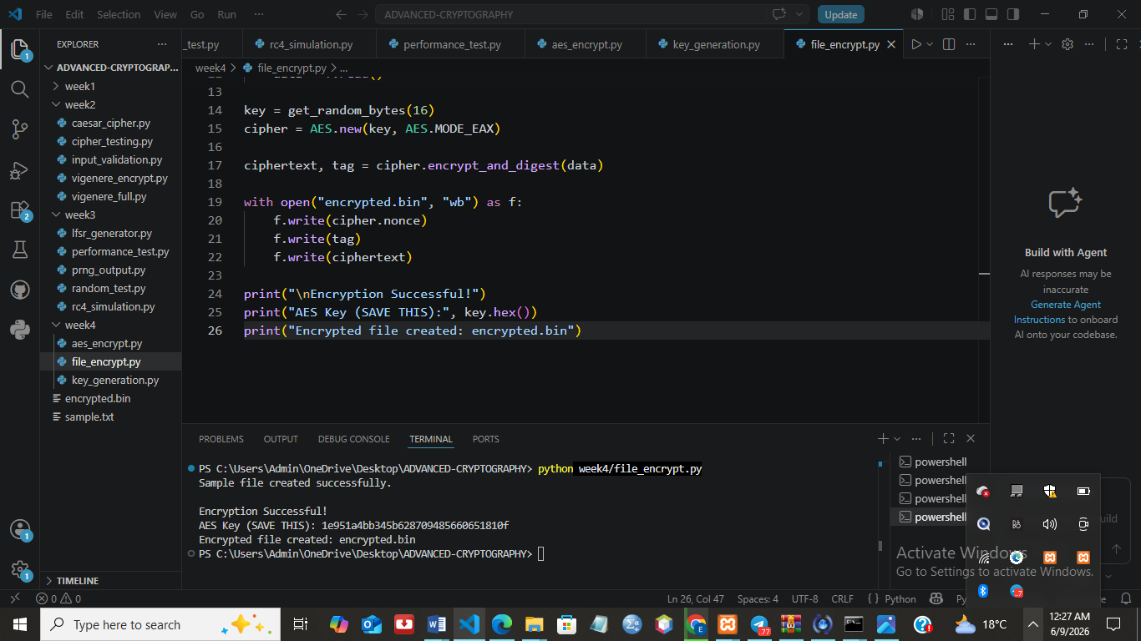
Fig 3: File Encryption Demonstration
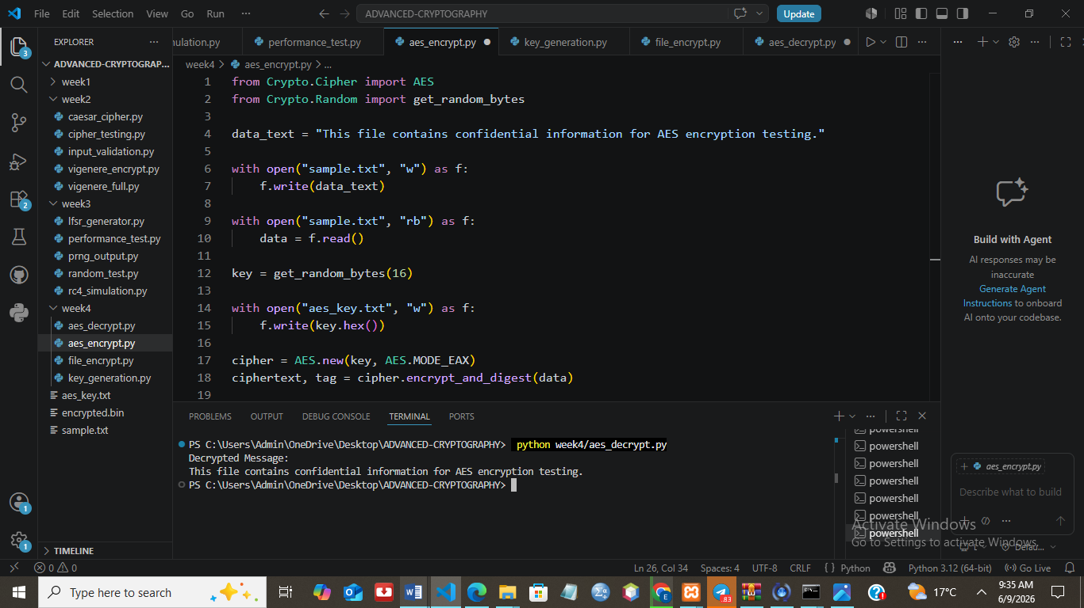
Fig 4: Decryption Results
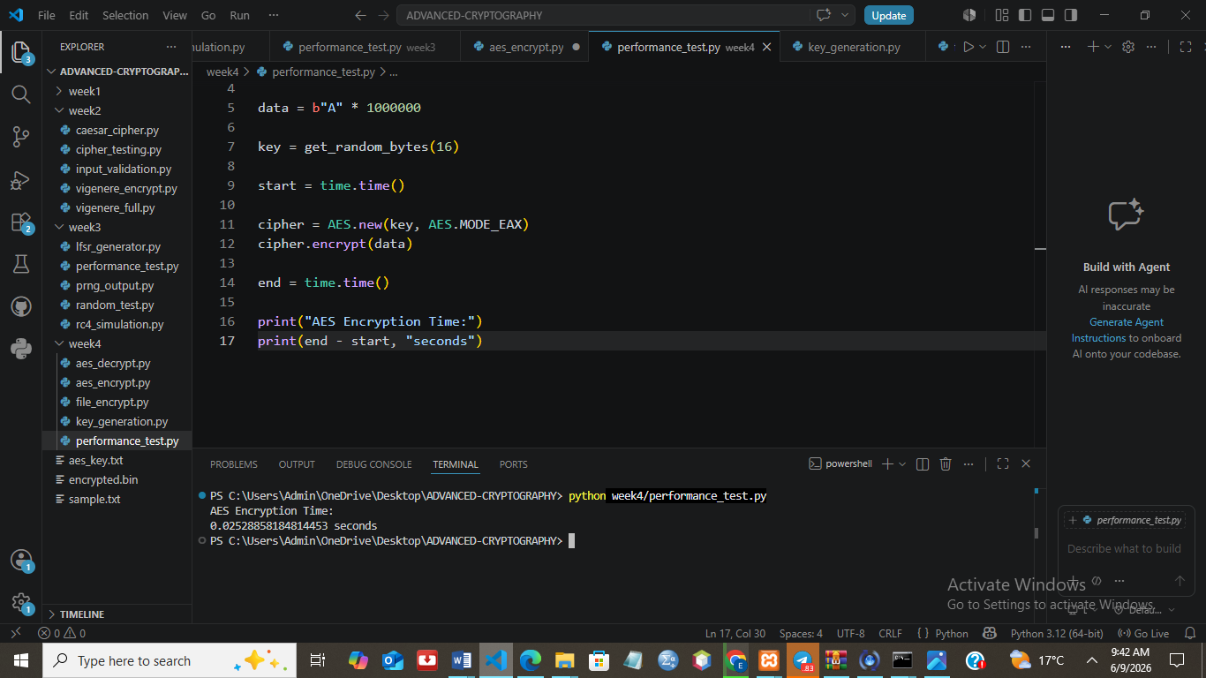
Fig 5: AES Performance Testing

STUDENT REFLECTION
This week I worked with AES encryption to secure files using a secret key. I learned how data is encrypted, stored and later decrypted safely. It also helped me understand the importance of key management and how strong encryption protects sensitive information in real systems.

WEEK FIVE: PUBLIC KEY CRYPTOGRAPHY (RSA)
Title:
Implementation of RSA Encryption and Key Management
Required Evidence
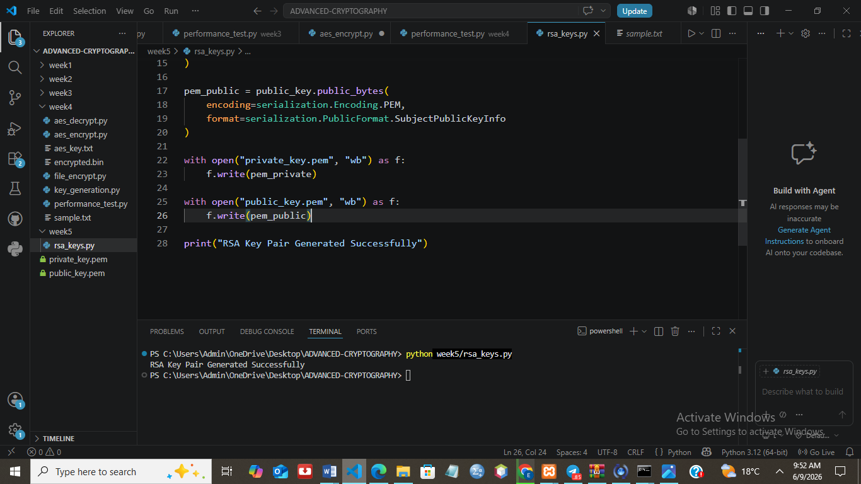
Fig 1: RSA Key Pair Generation
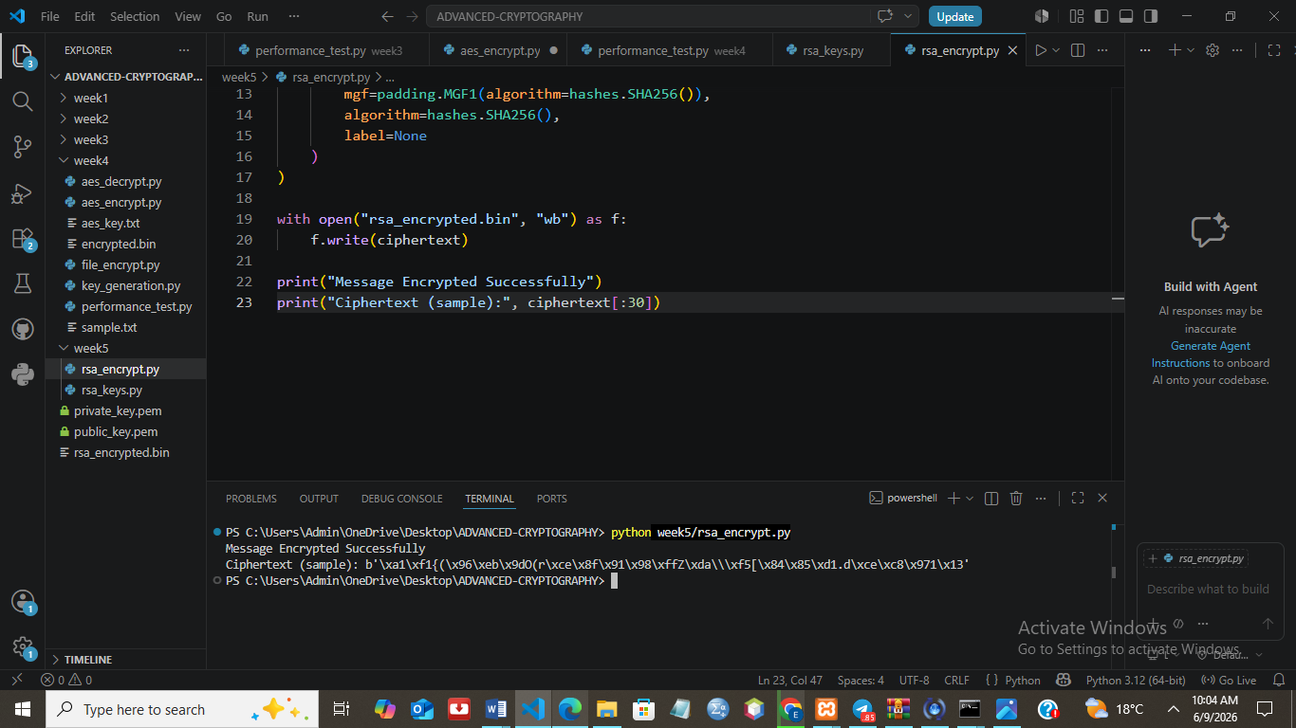
Fig 2: Public Key Encryption Process
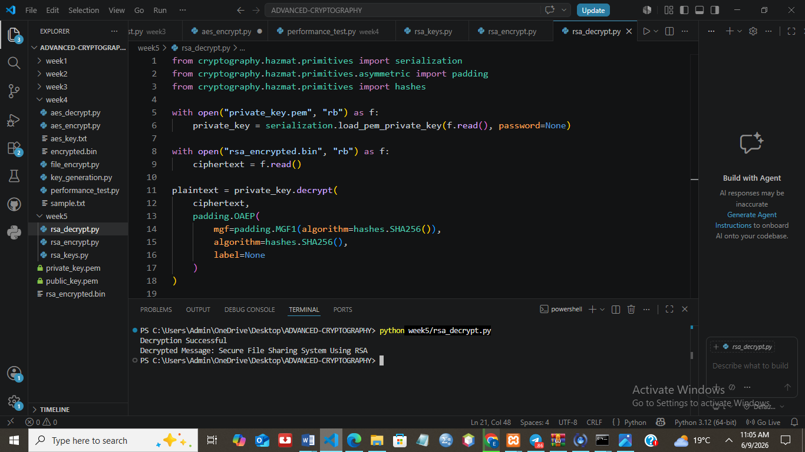
Fig 3: Private Key Decryption Results
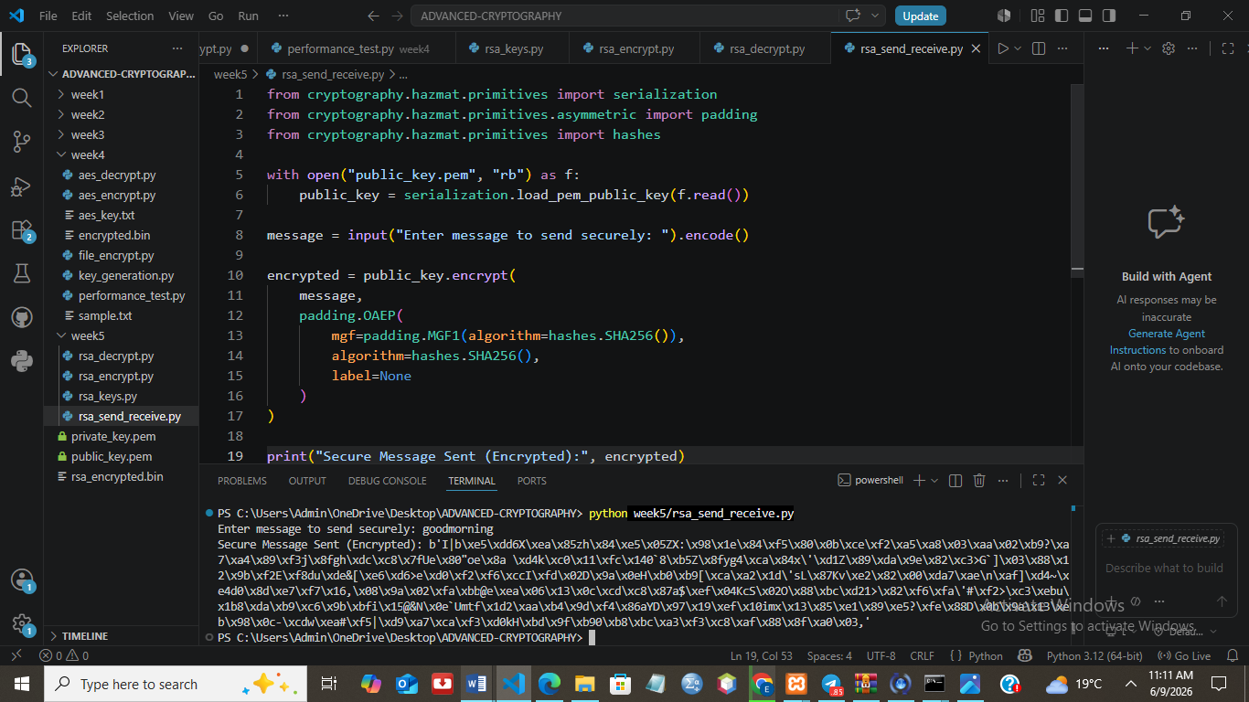
Fig 4: Secure Message Transmission
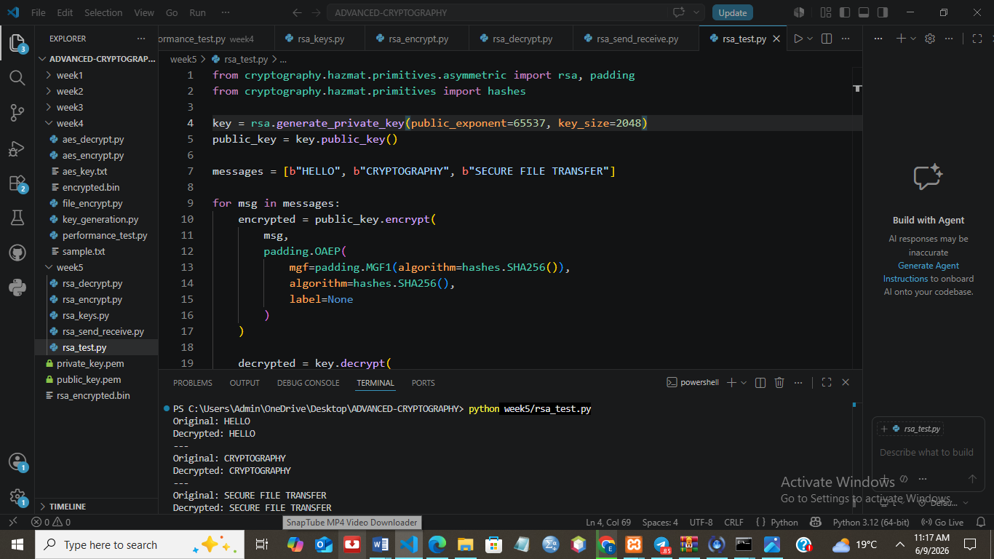
Fig 5: RSA Testing and Validation

STUDENT REFLECTION
This week I learned how RSA uses public and private keys to secure communication. I saw how data is encrypted with a public key and only decrypted with a private key. The exercises helped me understand how secure data can be shared safely over insecure networks.

